SHIPPING

Case 1 (Same Country): Product has been added to container successfully

- At first, you have to create C-code=71 from ‘Customers’
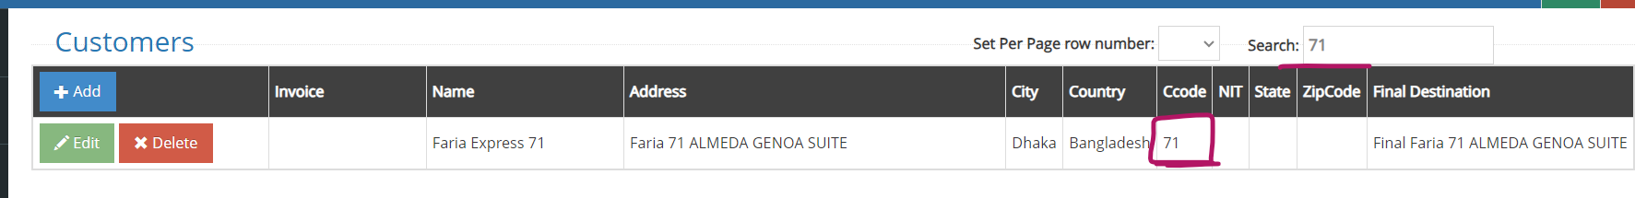
- Create Product Code, Set Alphanumeric Code= FARACCCRD804, Numeric Code= 7102010602. Here, one thing you must have to check that is, first 2/3 digit of Numeric must have to match with C-code.

Example: C-code= 718 , Numeric Code= 7182010602
C-code= 71 , Numeric Code= 712010602
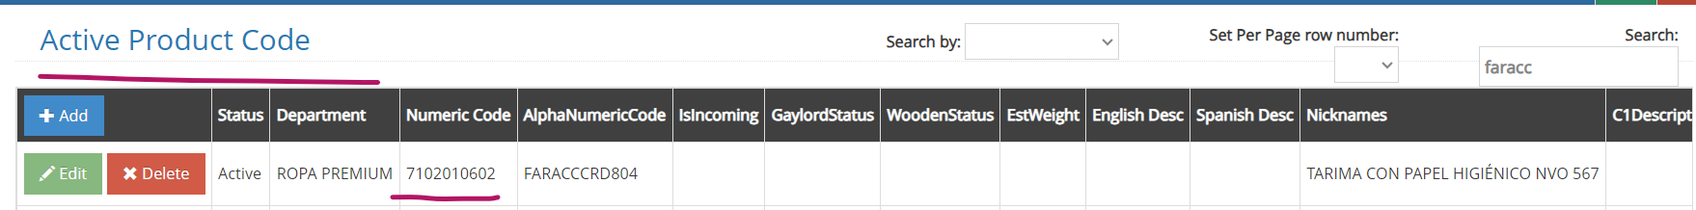

- Then create container under the same Customer, Weigh Product.

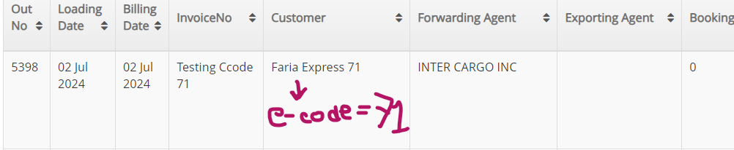
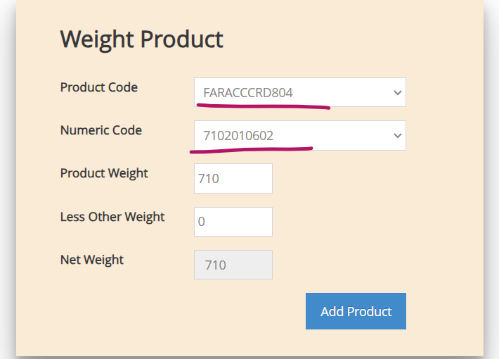

- Now Load Product

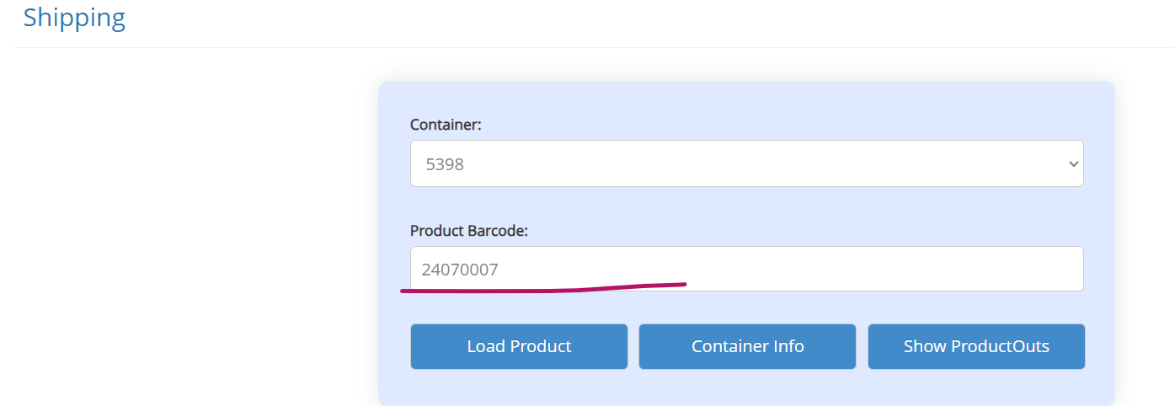

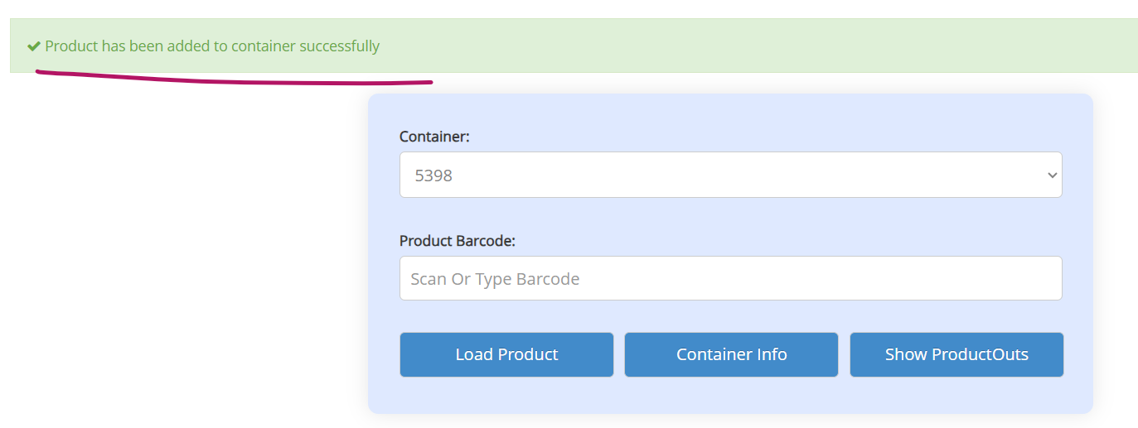

Case 2 (Cross Country): Product has been added to container successfully

- At first, you have to create C-code=71 from ‘Customers’
- Create Product Code, Set Alphanumeric Code= FARACCCRD804, This time under the same Alphanumeric Code we have 2 different Numeric Code= 7102010602, 6102010602.

Here, one thing you must have to check that is, First 2/3 digit of Numeric must have to match with C-code.

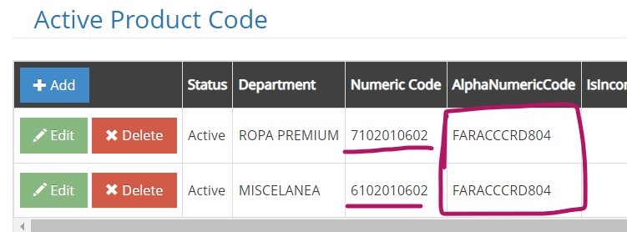

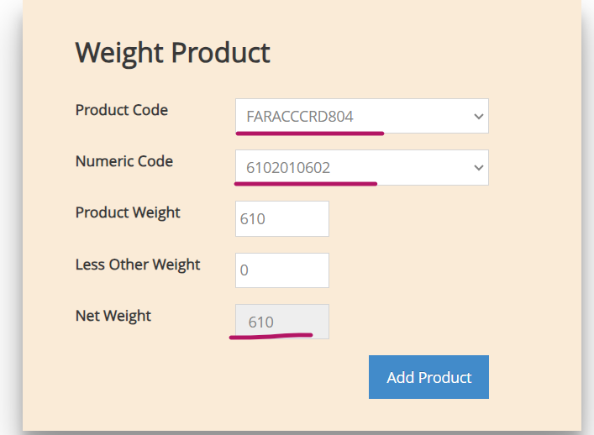
- Now we are weighing Numeric Code= 6102010602 - this product.

- Load Product

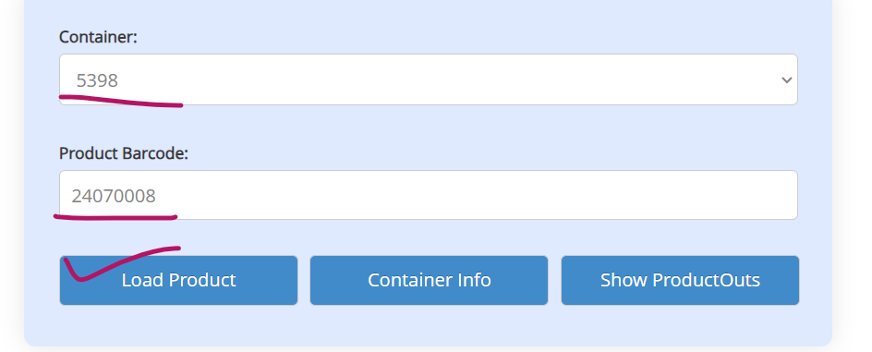
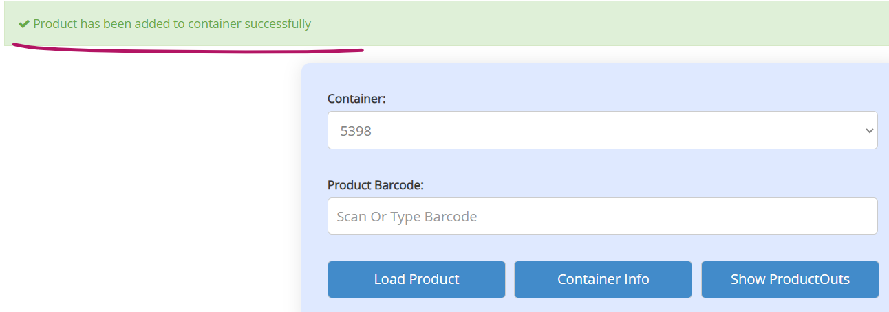

NB: This time, Numeric Changed 6102010602 to 7102010602 after Loading the product.

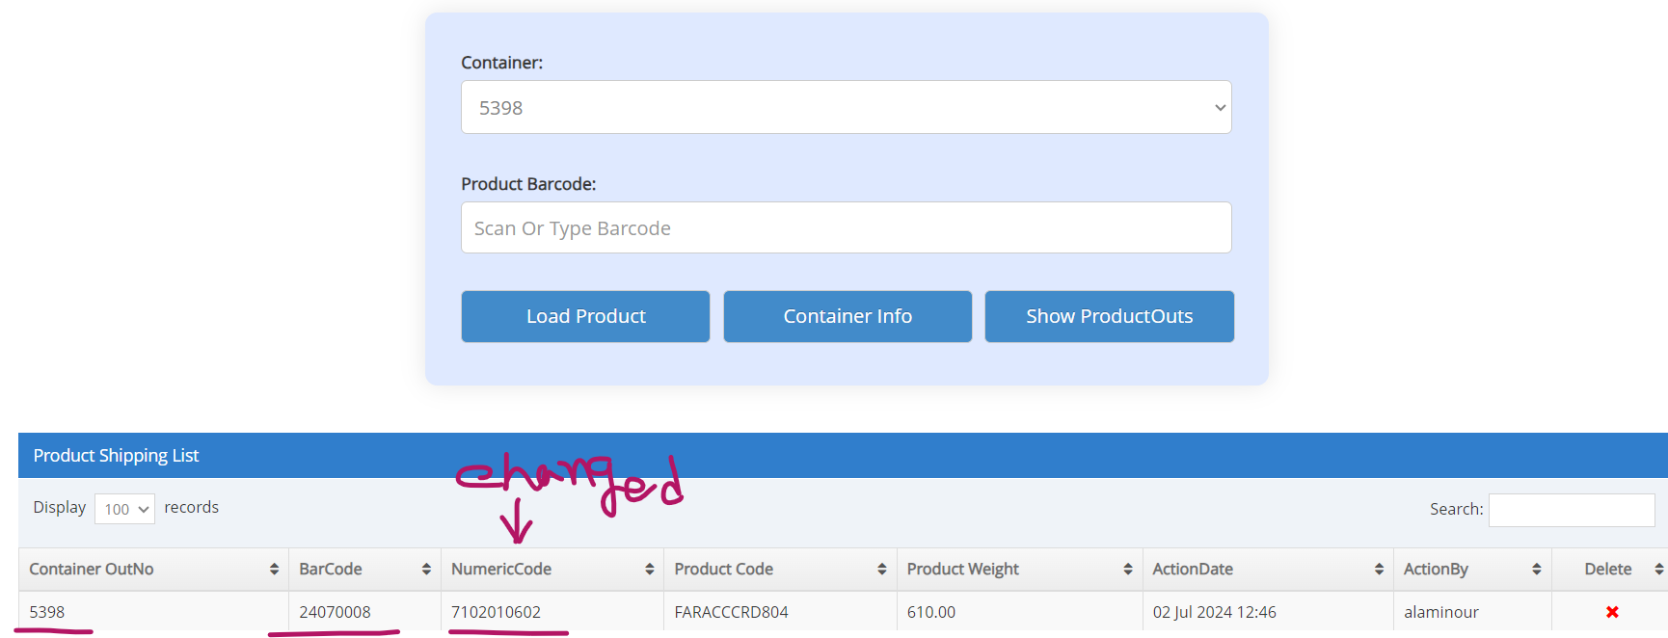

Case 3 (Country Code Mismatch): This Product did not match according to Country Code

- At first, you have to create C-code=71 from ‘Customers’
- Now this, you want to add different Alphanumeric code, Numeric Code where there is no matching with C-code=71

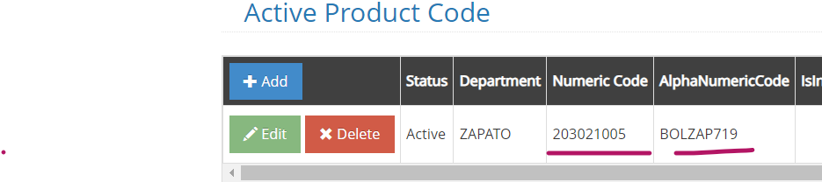

- Weigh Product
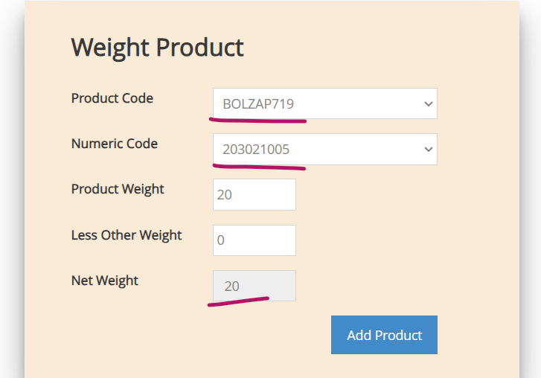

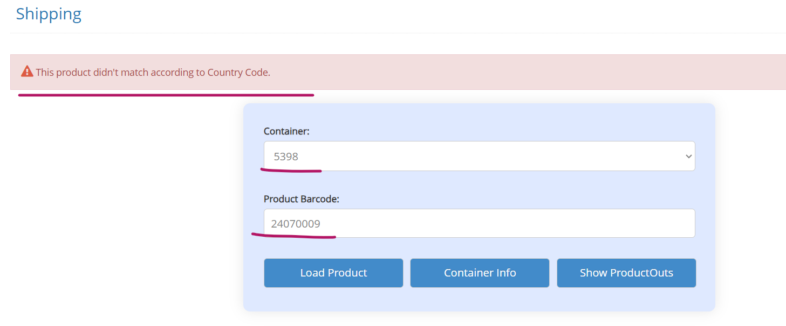
- Now, load product. As there is no matching with C-code. That’s why, Product won’t add.
C-code= 71 but Numeric Code= 203021005

